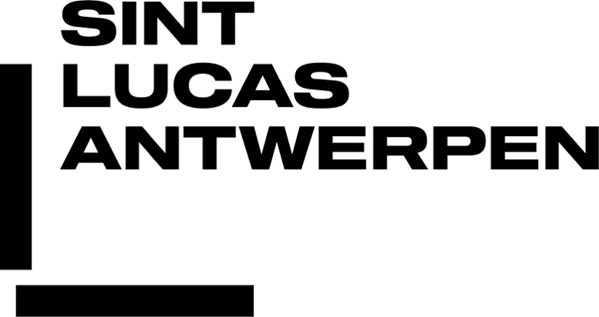

Advanced Master In Artistic Research Within A Socio-Political Context
APPLICATION FORM 2020-2021

PERSONAL INFORMATION

Surname: __________________________________________________________

First name: _________________________________________________________

Address: ___________________________________________________________

Place: _____________________________________________________________

Zip/Postal code: _____________________________________________________

Country: ___________________________________________________________

E-mail: ____________________________________________________________

Phone: ____________________________________________________________

Mobile: ____________________________________________________________

Web address: _______________________________________________________

Nationality: _________________________ Date of birth: _____________________

Spoken languages: ___________________________________________________

English language certificate (if applicable): _________________________________

Gender: F / M / X
Pronoun: She / They / He

How did you hear about the Master of Research in Art & Design?

___________________________________________________________________

APPLICATION PROCEDURE

Please prepare the following information and send everything at once in one file. We will not accept incomplete files or applications spread over several mails. If you want to send us a large file, please use WeTransfer or Dropbox.

Curriculum Vitae
Provide an overview of education, previous employment, commissions, exhibitions, publications, grants,…

Copies of previous educational certificates and/or diplomas
Send us a digital copy of all relevant diplomas and diploma attachments.

Short description of your practice
A brief statement on your art or design practice. Maximum 500 words

Research proposal
A short description of the objectives and purpose of your research proposal. Maximum 500 words

Personal motivation
Why would you like to join this advanced MA program and give an indication of your needs and expectations. Maximum 200 words

Portfolio
Provide several photographic images of your work or indicate web address of your digital portfolio.

PRACTICAL INFORMATION

Application forms can be sent by post or by e-mail.

By post:
Petra Van Brabandt
Sint Lucas Antwerpen
Advanced Master in Artistic Research
Van Schoonbekestraat 143
2018 Antwerpen
Belgium

By e-mail:
Petra.vanbrabandt@kdg.be
(large files to be sent using WeTransfer or Dropbox)

A jury will make a first selection based on your application file. After a positive first evaluation you will be invite you for an admission interview. At the latest you will be informed about this one month after the submission of your application file.
The academic year starts in October 2020 and ends in September 2021. The registration fee for a full academic year of 60 ECTS amounts to 2500 euro.

St Lucas Antwerp can provide you with any necessary official documents.

